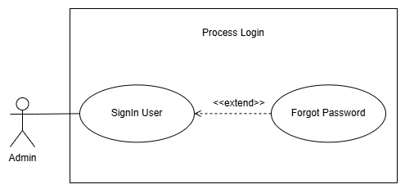
Figure 3.3: Process Login
Written Use Case: Process Login
Use Case Name: Signin User
Purpose: Allow the admin to access the system using their username/email and password.
Actors:
- Admin
Input Parameters:
- Username / Email
- Password
- New Password
- Confirm New Password
Output Parameters:
- Status – Login succeeded or failed
- Display the Dashboard
- Password successfully changed
Pre-Condition:
- Admin has an existing account in the system.
- Admin is on the Login page.
Post-Condition:
- Admin successfully logs in to the system.
- The Dashboard is displayed.
Successful Scenario:
- Admin opens the Login page
- Admin inputs their username/email and password
- Admin clicks the Sign In button
- The system validates the admin's username/email and password
- If valid, proceed to step 5.
- If invalid, display an error message
- The system displays the Dashboard
- If the admin forgets their password, the admin clicks the Forgot Password function
- The system displays the Forgot Password page
- Admin inputs their username/email
- Admin clicks the Send Verification Code button
- The system validates the entered username/email
- If valid, the system sends a verification code to the admin's registered email.
- If invalid, the system displays an error message.
- Admin enters the verification code
- The system validates the verification code
- If valid, proceed to step 13.
- If invalid, display an error message.
- Admin enters a new password and confirms the new password
- Admin clicks the Change Password button
- The system validates the new password
- If valid, the system changes the admin's password.
- If invalid, display an error message.
- The system redirects the admin to the Login page
- Admin enters the new password and clicks the Sign In button
- The system validates the new password
- The system displays the Dashboard
Exception Scenario:
- If the admin inputs an incorrect username/email or password:
- The system displays the message “Invalid username/password. Please try again.”
- If the admin inputs a username/email that is not recognized by the system when using Forgot Password:
- The system displays an error message indicating that the account was not found.
- If the admin enters an incorrect or expired verification code:
- The system displays an error message and allows the admin to request a new verification code.
- If the admin enters a new password and confirmation password that do not match:
- The system displays the message “New password and confirmation do not match.”
Additional Remarks:
- The admin must have an existing account to access the system.

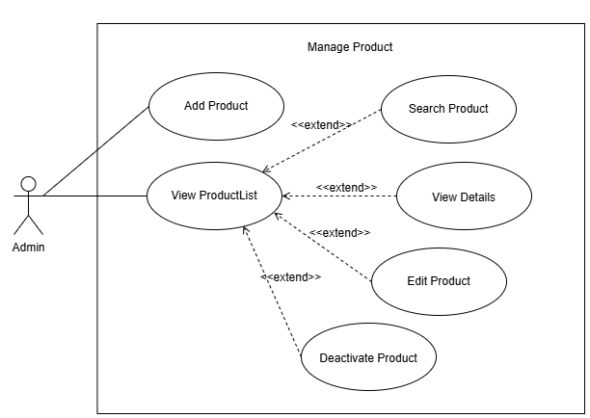
Figure 3.4: Manage Product
Written Use Case: Manage Product
Use Case Name: Add Product
Purpose: Allows the admin to add a new product to the system by entering its product
details, inventory information, pricing, and category.
Actors:
- Admin
Input Parameters:
- Product Name
- Brand
- Description
- Quantity
- Selling Price
- Reorder Level
- Category
- Search Keyword
Output Parameters:
- Product successfully added
- Product successfully updated
- Product information saved in the system
- Initial product status
- Product successfully deleted
Pre-Condition:
- Admin is successfully logged in to the system.
- Admin has access to the Product Management function.
- A product category is available in the system.
Post-Condition:
- The new product is saved in the system.
- The product is assigned to the selected category.
- The product information is stored in the database.
- The product is initially set to Unavailable.
Successful Scenario:
- Admin opens the Product page.
- Admin clicks the Add Product button.
- The system displays the New Product page.
- Admin enters the Product Name.
- Admin enters the Brand.
- Admin enters the Description of the product.
- Admin selects the Inventory Tracking Type:
- Non-Serialized
- Serialized
- Admin enters the Quantity.
- Admin enters the Selling Price.
- Admin enters the Reorder Level.
- Admin selects the Category of the product.
- The system displays the initial status as Unavailable.
- Admin reviews the entered product information.
- Admin clicks the Add Product button.
- The system validates the entered product information.
- If valid, proceed to step 16.
- If invalid, the system displays an error message.
- The system saves the product information.
- The system adds the product to the product list.
- The system displays a confirmation that the product was successfully added.
Exception Scenario:
- If the admin leaves a required field empty:
- The system displays an error message requiring the admin to complete the field.
- If the admin does not select a category:
- The system displays an error message requiring the admin to select a category.
Additional Remarks:
- The initial status of a newly added product is Unavailable.
- Stock is updated when products are received through the Delivery process.
- The admin can choose between Serialized and Non-Serialized inventory tracking.

Written Use Case: Manage Product
Use Case Name: View ProductList
Purpose: Allows the admin to view the complete information of an existing product,
search for a specific product and perform actions such as editing, deleting, or view the
details of the selected product.
Actors:
- Admin
Input Parameters:
- Product Keyword
- Product Name
- Brand
- Description
- Selling Price
- Reorder Level
- Category
Output Parameters:
- Updated product information
- Confirmation that the product was successfully updated
- Confirmation that the product was successfully deleted
- List of matching products
- Product information
Pre-Condition:
- Admin is successfully logged in to the system.
- The product already exists in the system.
- Admin has access to the Product Management function.
Post-Condition:
- The selected product information is displayed to the admin.
- If the admin edits the product, the updated information is saved in the system.
- If the admin deletes the product, the product is removed from the active product
records.
Successful Scenario:
- Admin opens the Product page.
- Admin view the product list.
- Admin may also search the product to be viewed.
- The system displays the matching product.
- Admin selects the product.
- Admin may select View Details function.
- The system displays all the details of the selected product.
- Admin may select Edit Product.
- The system displays the existing product information in editable fields.
- Admin modifies the necessary product information.
- Admin reviews the updated information.
- Admin clicks the Save Changes button.
- The system validates the updated product information.
- If valid, proceed to step 14.
- If invalid, the system displays an error message.
- The system saves the updated product information.
- The system displays a confirmation that the product was successfully updated.
- Admin may select Deactivate Product.
- The system displays a confirmation message asking the admin to confirm the deactivation.
- Admin confirms the deactivation.
- The system validates the deactivation request.
- The system hides the product from the active product records.
- The system displays a confirmation that the product was successfully deactivated.
Exception Scenario:
- If the admin leaves a required field empty:
- The system displays an error message requiring the admin to complete the field.
- If the entered information is invalid:
- The system displays an error message and does not save the changes.
- If the product cannot be found:
- The system displays a message indicating that the product does not exist.
- If the admin cancels the deletion:
- The system cancels the deletion process and keeps the product unchanged.
- If the product cannot be deleted because it is associated with existing
transactions:
- The system displays a message indicating that the product cannot be deleted.
Additional Remarks:
- Only authorized admins can edit product information.
- Changes made by the admin should be saved in the product record.

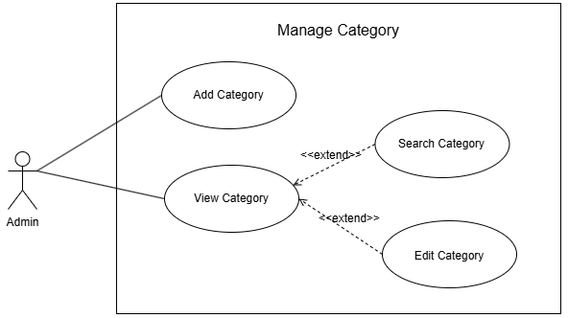
Figure 3.5: Manage Category
Written Use Case: Manage Category
Use Case Name: Add Category
Purpose: Allow the admin to add a new product category to the system.
Actors:
- Admin
Input Parameters:
- Category Name
Output Parameters:
- Category successfully added
- Confirmation message
Pre-Condition:
- Admin is logged in to the system.
- Admin has access to the Manage Category function.
Post-Condition:
- The new category is saved in the system.
- The added category is displayed in the category list.
Successful Scenario:
- Admin opens the Category page
- Admin clicks the Add Category button
- The system displays the Add Category form
- Admin inputs the category name and description
- Admin clicks the Save/Add Category button
- The system saves the new category
- The system displays a confirmation message that the category was successfully added
- The system displays the newly added category in the category list
Exception Scenario:
- If the category already exists in the system:
- The system displays an error message indicating that the category already
exists.
Additional Remarks:
- The category name must be unique.

Written Use Case: Manage Category
Use Case Name: View Category
Purpose: Allows the admin to view the complete list of an existing category, search for a
specific product category and perform action such as editing the selected category.
- Admin
Input Parameters:
- Category Name
Output Parameters:
- Updated category information
- Confirmation message
- List of matching categories
Pre-Condition:
- Admin is logged in to the system.
- The category already exists in the system.
- Admin has accessed the View Category function.
Post-Condition:
- The category information is successfully updated.
- The updated category information is displayed in the system.
Successful Scenario:
- Admin opens the Category page
- Admin views the list of available categories
- Admin may also search the list of available categories
- Admin selects the category to be edited
- Admin clicks the Edit Category button
- The system displays the existing category information
- Admin modifies the category information
- Admin clicks the Save Changes button
- The system validates the updated category information
- If valid, proceed to step 9.
- If invalid, the system displays an error message
- The system updates the category information
- The system displays a confirmation message that the category was successfully updated
- The system displays the updated category information
Exception Scenario:
- If the updated category name already exists:
- The system displays an error message indicating that the category name is
already existed.
- If the selected category cannot be found:
- The system displays an error message indicating that no category match your
search.
Additional Remarks:
- Edit Category and Search Category is an extension of the View Category.
- Only authorized admins can edit category information.
- The system should save the updated information immediately after a successful update.

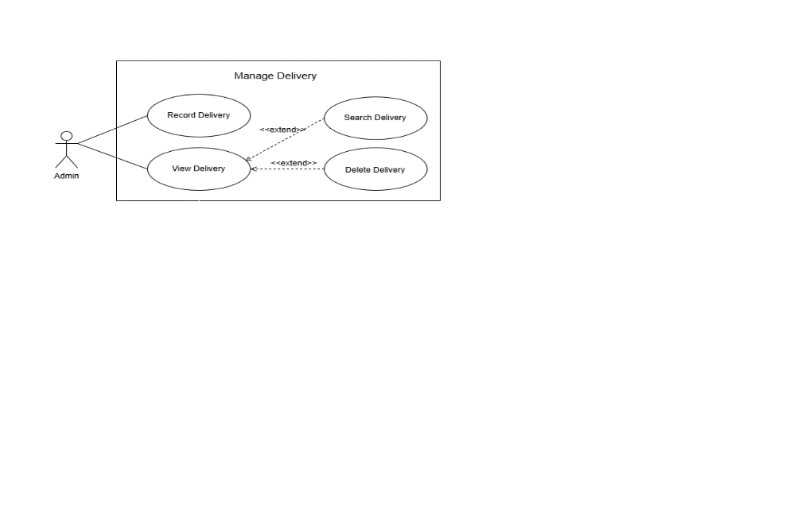
Figure 3.6: Manage Delivery
Written Use Case: Manage Delivery
Use Case Name: Record Delivery
Purpose: Allows the admin to record incoming products and update the inventory by
selecting the products received and entering their received quantities.
Actors:
- Admin
Input Parameters:
- Batch ID
- Delivery Date
- Received By
- Product
- Received Quantity
Output Parameters:
- Delivery record successfully saved
- Selected products recorded in the delivery
- Inventory quantity updated
Pre-Condition:
- Admin is successfully logged in to the system.
- Admin has access to the Manage Delivery function.
- Products to be received already exist in the system.
Post-Condition:
- The delivery record is successfully saved.
- The selected products are recorded under the delivery.
- The received quantity is added to the product's inventory.
- The delivery can be viewed through the Search Delivery function.
Successful Scenario:
- Admin opens the Delivery page.
- Admin clicks the Receive Products button.
- The system displays the Receive Products page.
- The system displays the Batch ID.
- The system displays the Delivery Date.
- The system displays the Received By information.
- Admin searches for the product to be received.
- The system displays the available products.
- Admin selects the product to include in the delivery.
- The system adds the selected product to the Products to Receive section.
- Admin enters the received quantity for the selected product.
- Admin repeats steps 7–11 if there are additional products to receive.
- The system displays the selected products and total quantity.
- Admin reviews the delivery information and selected products.
- Admin clicks the Receive Products button.
- The system validates the delivery information and received quantities.
- If valid, proceed to step 17.
- If invalid, the system displays an error message.
- The system saves the delivery record.
- The system updates the inventory based on the received quantities.
- The system displays a confirmation that the products were successfully received.
Exception Scenario:
- If the admin does not select or emptied the important details:
- The Receive Products button will not be clickable.
- If the product is no longer available in the system:
- The system displays an error message and does not add the product to the
delivery.
Additional Remarks:
- The Batch ID identifies the delivery record.
- The Delivery Date records when the products were received.
- The Received By field identifies the admin who recorded the delivery.
- Receiving products updates the inventory quantity.
- Only products selected in the Products to Receive section are included in the delivery.
Written Use Case: Manage Delivery
Use Case Name: View Delivery
Purpose: Allows the admin to view the complete list of an existing delivery, search the
specific delivery and perform action such as deleting the selected delivery.
Actors:
- Admin
Input Parameters:
- Delivery Keyword
Output Parameters:
- List of matching deliveries.
- Delivery record deleted
- Confirmation of successful deletion
Pre-Condition:
- Admin is successfully logged in to the system.
- Admin has access to the Manage Delivery function.
- The delivery record already exists in the system.
Post-Condition:
- The system displays the delivery records matching the admin's search criteria.
- The selected delivery record is deleted from the system.
- The delivery record is no longer displayed in the active delivery records.
Successful Scenario:
- Admin opens the Delivery page.
- Admin searches for the delivery record to be viewed.
- The system displays the matching delivery record.
- Admin selects the delivery record.
- Admin clicks the Delete Delivery option.
- The system displays a confirmation message asking the admin to confirm the deletion.
- Admin confirms the deletion.
- The system validates the deletion request.
- The system deletes the selected delivery record.
- The system displays a confirmation that the delivery record was successfully
deleted.
Exception Scenario:
- If the delivery record cannot be found:
- The system displays a message indicating that the delivery record does not exist.
- If the admin cancels the deletion:
- The system cancels the deletion process and keeps the delivery record
unchanged.
- If the delivery record cannot be deleted because it is associated with inventory
transactions:
- The system displays a message indicating that the delivery record cannot be
deleted.
Additional Remarks:
- The system should require confirmation before deleting a delivery record.
- Only authorized admins can delete delivery records.
- Delivery records associated with inventory transactions should be protected from accidental deletion.

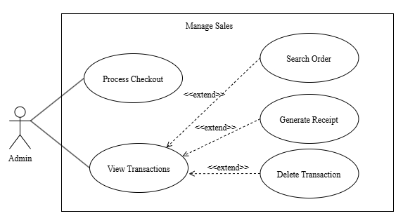
Figure 3.7: Manage Sales

Written Use Case: Manage Sales

Use Case Name: Process Checkout
Purpose: Allows the admin to process a customer's purchase by entering customer
information, selecting products, and completing the payment transaction.
Actors:
- Admin
Input Parameters:
- Customer Full Name
- Customer Phone Number
- Customer Email Address
- Customer Address
- Product
- Quantity
- Payment Type
- Payment Method
- Date Purchased
Output Parameters:
- Customer order
- Order summary
- Total purchase amount
- Payment status
- Updated product inventory
- Checkout confirmation
Pre-Condition:
- Admin has an existing account in the system.
- Admin is logged in to the system.
- Products are available in the system.
Post-Condition:
- Customer order is successfully recorded in the system.
- Payment information is recorded.
- Product inventory is updated.
- The completed transaction is saved in the system.
Successful Scenario:
- Admin opens the Sales page.
- Admin selects New Checkout.
- The system displays the New Checkout page.
- Admin searches for an existing customer using their name, phone number, or email address.
- The system displays the matching customer information.
- If the customer exists, proceed to step 6.
- If the customer does not exist, proceed to step 7.
- Admin confirms the customer's information.
- Admin enters the customer's Full Name, Phone Number, Email Address, and Address.
- Admin searches for a product using the product name, code, brand, or category.
- The system displays the available products.
- Admin selects a product to add to the order.
- The system adds the selected product to the Selected Items section.
- Admin enters the quantity of the selected product.
- The system calculates the product subtotal.
- Admin repeats steps 8–13 if additional products need to be added.
- Admin selects the Payment Type, such as Full Payment or Installment.
- If payment type is Full Payment proceed to step 16.
- If payment type is Installment proceed to step 17.
- Admin selects the Payment Method, such as Cash.
- Admin selects Installment Term, such as 6 months.
- Admin enters customer’s Down Payment.
- Admin reviews the selected items and Order Summary.
- The system displays the number of items and the total amount.
- Admin clicks the Complete Checkout button.
- The system validates the customer, product, quantity, and payment information.
- If valid, proceed to step 21.
- If invalid, the system displays an error message.
- The system records the customer's order and payment information.
- The system updates the product inventory.
- The system displays a confirmation that the checkout was successfully completed.
- The system displays a checkout details.
- The admin selects Generate Receipt, the system will generates a receipt containing the order and customer information.
- The system displays the generated receipt to the admin.
Exception Scenario:
- If the admin does not provide the required customer information:
- The complete checkout button is not clickable and requires the admin to
complete the required fields.
- If the admin attempts to complete the checkout without selecting a product:
- The system prevents the checkout from being completed.
- If the admin does not select a payment type or payment method:
- The system requires the admin to provide the required payment information.
- If the admin clicks the Cancel button:
- The system cancels the current checkout process.

Additional Remarks:
- The system automatically calculates the subtotal and total purchase amount.
- The system displays the available quantity of each product.
- For serialized products, the required serial number must be entered before completing the checkout.
- The system must update the inventory after a successful checkout.

Written Use Case: Manage Sales

Use Case Name: View OrderList
Purpose: Allows the admin to view the complete list of all the recorded transaction,
search the specific transaction and perform action such as generate a receipt or deleting the
selected order transaction.
Actors:
- Admin
Input Parameters:
- Sales Order Name or Keyword
Output Parameters:
- Order details
- Generated receipt
- Updated order records after deletion
Pre-Condition:
- Admin has an existing account in the system.
- Admin is logged in to the system.
- Existing orders are recorded in the system.
Post-Condition:
- Admin can view the selected order's details.
- Admin can generate a receipt for the selected order.
- Admin can delete the selected order when necessary.
Successful Scenario:
- Admin opens the Sales page.
- Admin accesses the order records.
- The system displays the available order transaction list.
- The system displays the order's information, including the customer information, purchased products, quantities, prices, payment information, total amount, and order status.
- Admin can search for the specific order transaction.
- Admin may select Generate Receipt.
- If the admin selects Generate Receipt, the system generates a receipt containing the order and customer information.
- The system displays the generated receipt to the admin.
- Admin may return to the order details or search results.
- Admin may select Delete Order if the order needs to be removed.
- If the admin selects Delete Order, the system displays a confirmation message.
- Admin confirms the deletion of the order.
- The system deletes the selected order from the records.
- The system updates the order records and displays a confirmation that the order was successfully deleted.

Exception Scenario:
- If the Admin selects Delete Order but cancels the confirmation:
- The system does not delete the order and returns to the order details.
- If an error occurs while deleting the order:
- The system displays an error message and keeps the order in the system.
- If the Admin search a specific order and no match was displayed:
- The system displays an error message inciting no match can be found.
Additional Remarks:
- Generate Receipt, and Delete Order are functions performed within the View Order process.
- The admin can optionally first select an order before performing actions on it.
- The system should require confirmation before deleting an order.
- The generated receipt should contain the relevant customer, product, payment, and order information.

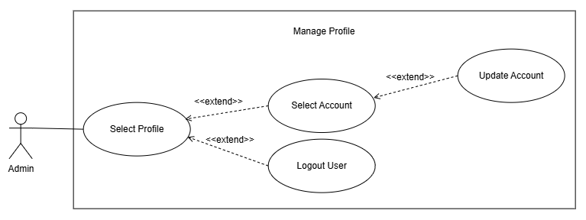
Figure 3.8: Manage Profile

Written Use Case: Manage Profile

Use Case Name: Select Profile

Purpose: Allows the admin to access their profile and account settings, where they can view and update their account information. The admin may also log out of the system.

Actors:
- Admin
Input Parameters:
- Full Name
- Email Address
- Username
- Current Password
- New Password
- Confirm Password
Output Parameters:
- Display the Account Settings page
- Updated account information
- Updated password
- Confirmation that changes were successfully saved
- Admin successfully logged out of the system
Pre-Condition:
- Admin has an existing account in the system.
- Admin is logged in to the system.
Post-Condition:
- Admin can view and manage their account information.
- Admin can update their profile information or password.
- If the admin chooses to log out, the system terminates the admin's
session and redirects them to the Login page.
Successful Scenario:
- Admin selects the Profile option from the system.
- The system displays the Account Settings page.
- The system displays the admin's profile information, including their full name, email address, and username.
- Admin reviews their account information.
- Admin may update their Full Name, Email Address, Username, or Change the current Password.
- Admin clicks the Save Changes button.
- The system validates the administrator's updated account information.
- If valid, proceed to step 8.
- If invalid, the system displays an error message.
- The system saves the updated account information.
- The system displays a confirmation that the account information has been
successfully updated.
Exception Scenario:
- If the admin inputs invalid or incomplete account information:
- The system displays an error message and requires the administrator to provide
valid information.
- If the admin enters an email address or username that is already associated
with another account:
- The system displays an error message indicating that the email address or
username is already in use.
Additional Remarks:
- When the admin selects Logout User, the system terminates the current session and redirects the administrator to the Login page.

